**Option 3: Weight Tracking App**

Cameron Michaud

Southern New Hampshire University

CS-360-X6159 Mobile Architecture & Programming

Raied Salman

July 16th, 2023

Out of the clients Mobile2App is considering, I’ve chosen to develop the weight tracking application that will be used by users to track their daily weight and goal weight. I plan on including more elements that can communicate more trends of the user’s weight and activity over a given time. For example, in addition to daily weight, I’d like to include the weekly/monthly trends in three separate divisions at the top of the app’s home screen with a graph beneath it to visually represent the user’s weight change over a given time span. The different time spans should change color to represent a desired change or a detrimental or neutral one. At the bottom of the home screen, I’d like to place a button displaying the last recorded weight with a visual indication to show whether the current weight is up-to-date or if needs to be updated. The purpose of having this weight as the last recorded will be the addition of an increment and decrement buttons to the side of the number that can allow a user to adjust the current weight with only a tap or two rather than manually entering in a new number each time. This core functionality is essential and should be clear to the need of users tracking their weight.

The different users for this app could contain a few different types. One is a user that simply wants to see the trends of their weight over time. A second might be more interested on the BMI calculation of their weight or a targeted amount of weight to lose per week to achieve their weight in a given time frame to have more proactive data on what they should be doing rather than using the app as a simple weight logger. For the users that just want to log their weight and see the trends in their weight over time, the features of different rate trends (weekly, daily, monthly) and a chart showing their weight changes over larger time frames will suffice for the major features. For the other users that want more of a command from the app to guide their weight loss, or simply more metrics on their health based on the information provided, the inclusion of a BMI reading and calculating the amount of weight to lose per week to reach their desired weight will probably suffice. Obviously, there will be users who would want to have features such as fitness exercise recommendations, but I think those are out of scope for the app, at least for its launch iteration.

The following are initial planning graphics for the different screens that will encompass the app. The main focuses when designing these different screens were maintaining something close to a 3:1 ratio as recommended by the Android style guidelines between background surfaces and non-text elements, maintaining consistant contrasting colors while maintaining low saturation values that aren’t difficult to look at, and clear navivigation icons to indicate to the user how to navigate the app. The sequence of screens is related to how users will encounter each screen. First the user will land on the login screen, then move to their dashboard that will provide all the quick reference information the app contains, with easy addtions to the database by entering their weight through a widgit brought up by a button at the bottom of the screen. From here, the user can use the sidebar menu to navigate to other screens or tap the account icon to log out or view their settings. The BMI screen is not interactable and instead responds to the last weight input, and the stats screen allows users to add weight entries for days they missed, or delete/edit entries. Settings are mainly for BMI reading & theme preference, as well as the ability to select their unit measurement (Imperial or Metric). To notify the user when they reach their goal weight, I plan on making the graph line gold if I can and sending a notification through the phone. Every time a weight is modified or added, or when a setting is changed, I plan on these features reaching out to their respective databases to alter and pull for user information to display.

**Account Screens**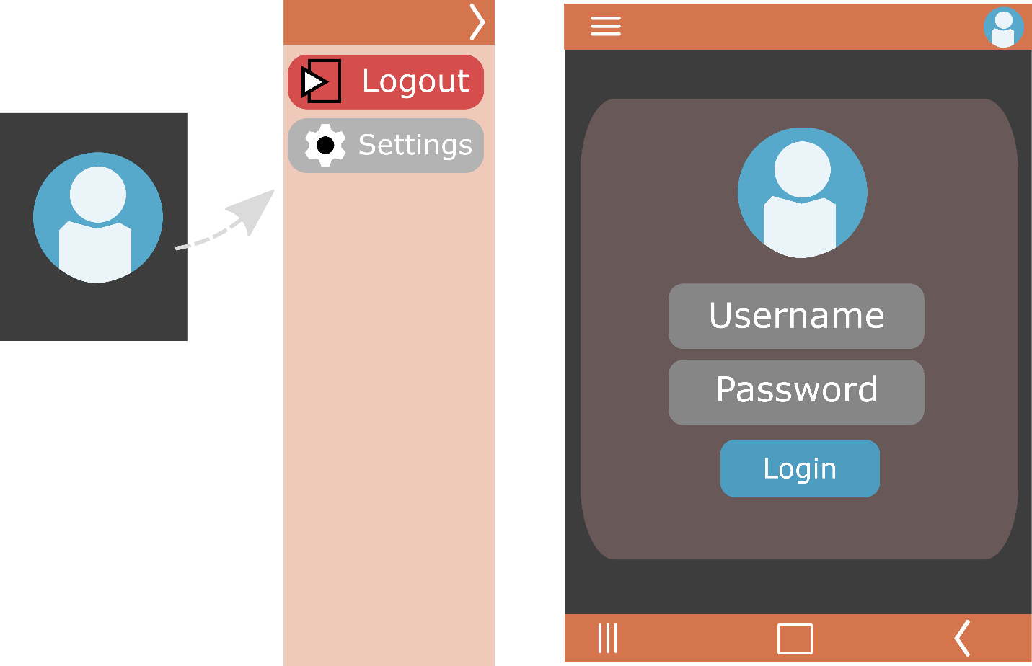

**Activity Screen**

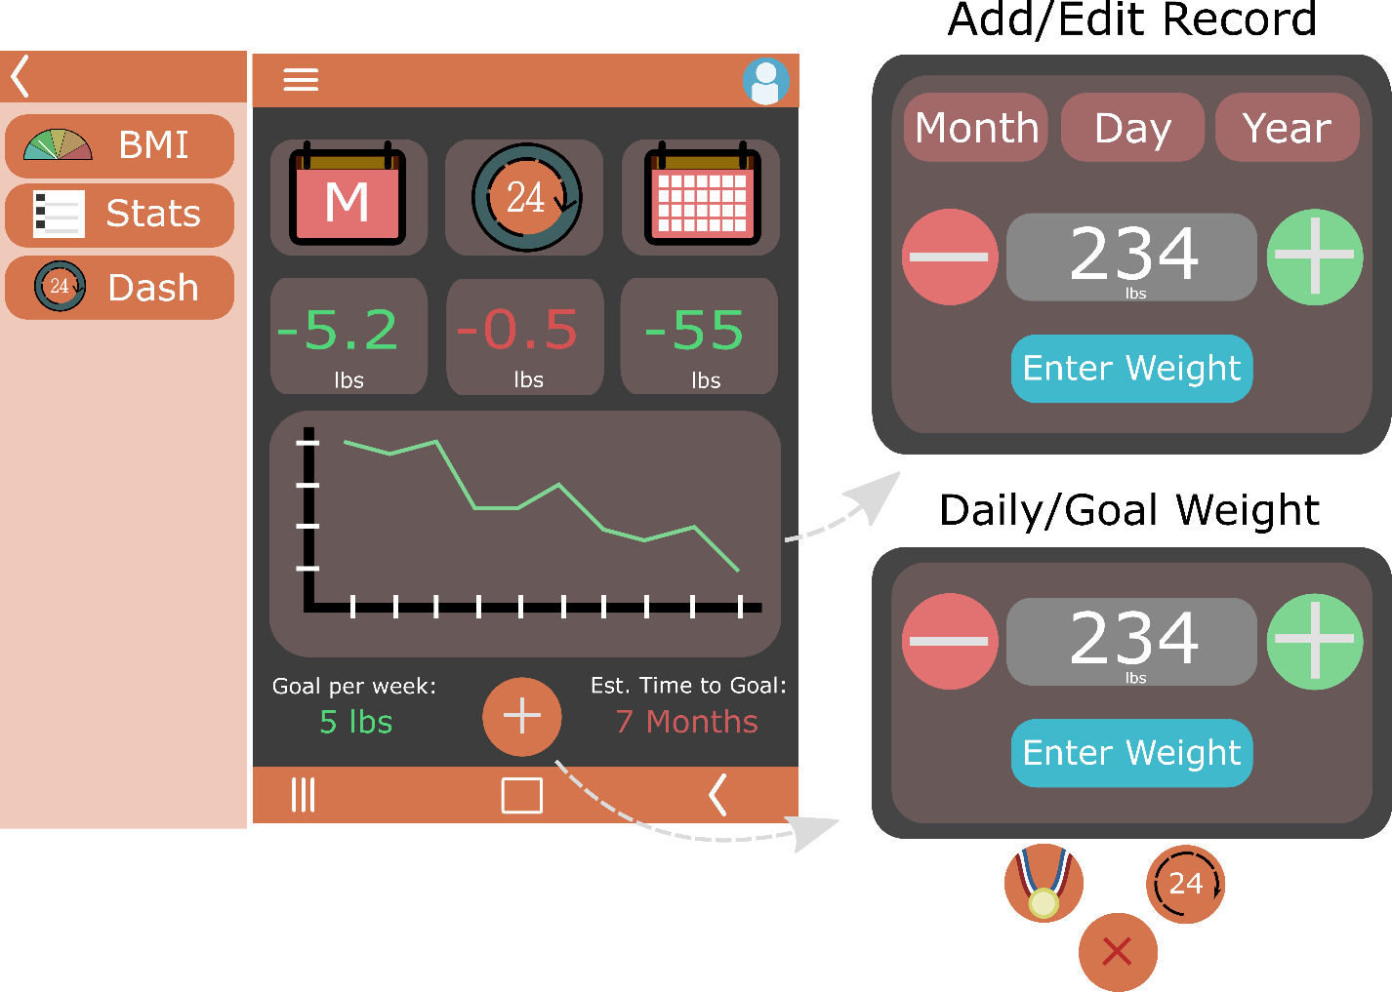

**BMI Screen**

**Stats page (Add, Update & Delete Entries)**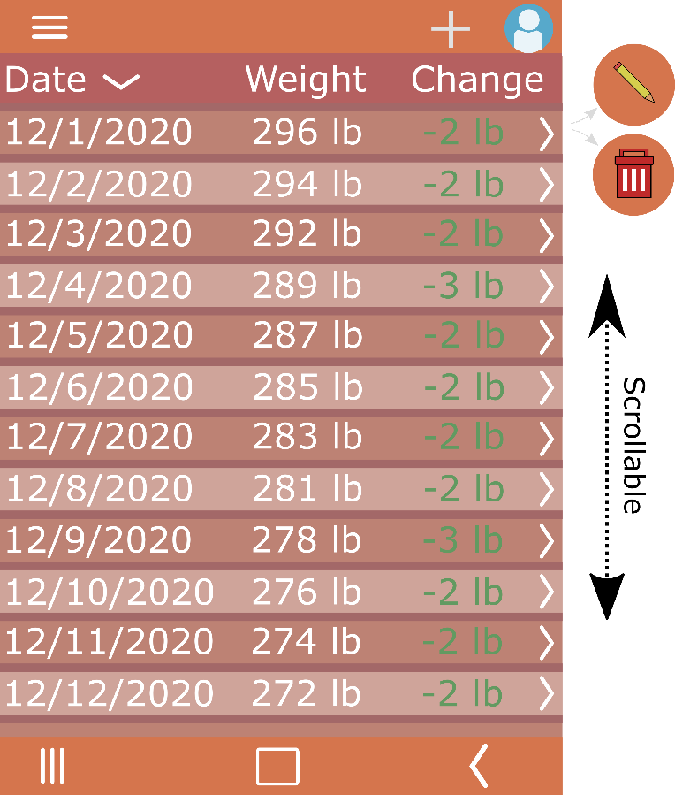

**Settings Page**

